

PROJECT MANAGEMENT | CAD DEPARTMENT

Room Details Checklist

**Project Name:**

**Project Manager Name:** David Ketchum

**Project Sponsor:** David Ketchum

**Project Team Member Names:** All CAD Customers

**Date:** 06-02-2017

**Prepared by:** Alex Lundin

# Table of Contents

## RISERLAYOUT command

## RD.dwg file

## Room Details Index

## Additional Room Items

## Attributes

## Set ECLU connection states

## Scale rectangle in model space and add additional items

## Repeat 3-7

## Use RDVIEWPORTS to set up all viewports in paper space

# Room Details Checlist

## RISERLAYOUT command

* **Complete RISERLAYOUT command (see Riser Checklist)**
  + The script creator will create all necessary extractions
  + It will also create all necessary templates

## RD.dwg file

* **Automation Scope**
  + This area describes what the Automation scope is, the functions are still in development.
  + In Scope
    - Rooms with:
      * Room controllers
        + Bridges
        + Occupancy
        + Switches
        + Input devices
  + Out of scope
    - Panel and zone controller devices
    - Any 1 port devices that don’t fit on room controllers
    - Connections from splitters to 1 port devices
    - Any Non DLM parts
* **Build Rooms in the RD.dwg file**
  + The RD file is used to build a collection of all the Room Details on the project
  + The RISERLAYOUT script will save a blank template into your project folder as RD.dwg
  + After the RISERLAYOUT script finishes, use the GRD lisp function to read the information from the text extraction into the drawing and Generate the Room Details
  + Every Room gets a complete bill of materials, showing exactly what was on the layouts
  + Steps:
  + Open the RD.dwg file
  + Type GRD to start the command to build the Rooms within scope

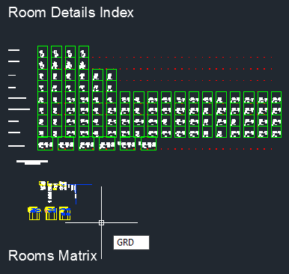

* **Follow steps 3 through 8 to add any additional items to the Rooms created by the GRD function**
  + There are supporting blocks and drawing utilties for adding items to this file
  + Each action step has a Example demonstrating on a Example Room 101

## Room Details Index

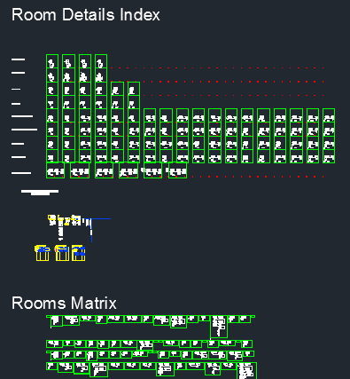

* **Find the Rooms Matrix in the AutoCAD file and start from top left of it**
  + Example: Locate the first Bill of Materials Example Room 101

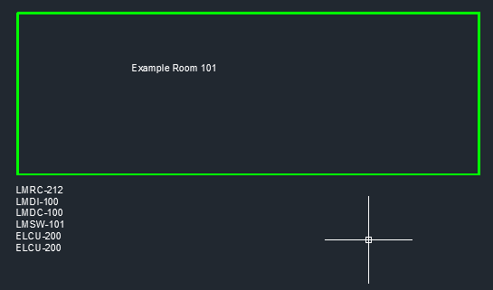

* **Navigate to location below to find the Excel Sheet for the Room Details Index**
  1. C:\WS_Blocks\Default\CAD Instructions
     1. This location for the Excel Index is the same for any Room, not specific to Example Room 101

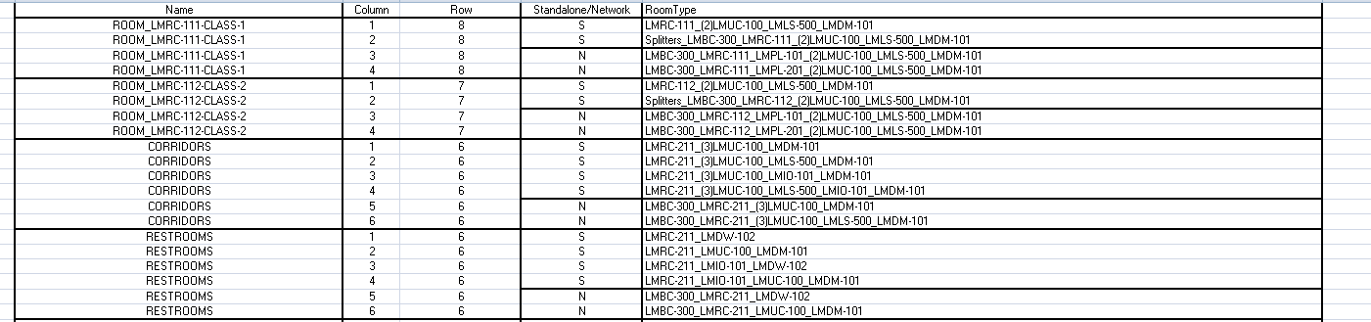

* **Choose the Room Type that is closest to the Bill of Materials**
  1. Each block holds several options under the Room Type visibility state
  2. Find the Room Type, column F, that is the closest match to the bill of materials for the room
  3. Next, use columns C and D to find it in the AutoCAD file
     1. Example: The block that is closest to Example Room 101 is
        1. Block: TWO-ZONE-SPACE
        2. RoomType: LMRC-212_LMDC-100_LMDM-101_LMDM-101

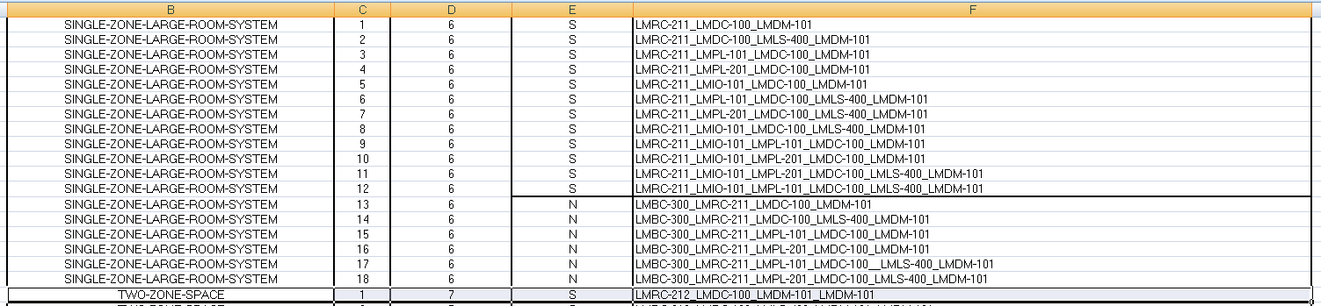

* 1. Each of the blocks in the excel file is inside AutoCAD and organized by row and column
     1. Example: The block that is closest to Example Room 101 is
        1. Row 1
        2. Column 7

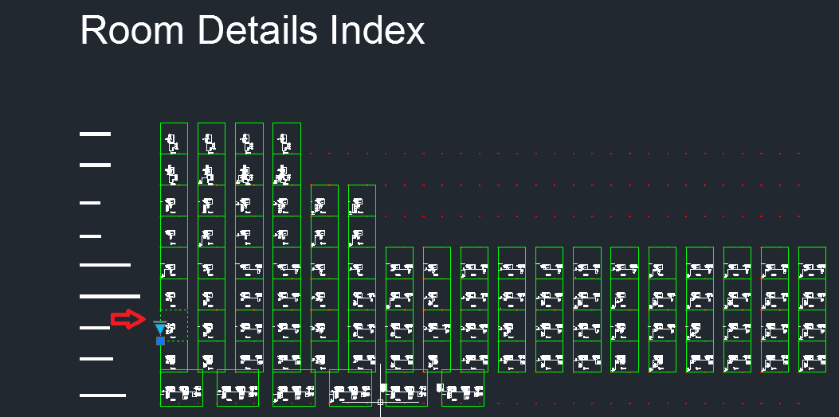

* **Insert starting block in the Rooms Matrix near the created viewport**
  1. The blocks are stored inside the RD file above the Rooms Matrix
     1. They are organized by column and row, mirroring the excel index
  2. The blocks are also on the Room Details area of the tool palette under the Rooms tab
     1. The palette contains the main block definition for each collection of Rooms
        1. Example: The block that is closest to Example Room 101 is
           1. TWO-ZONE-SPACE

LMRC-212_LMDC-100_LMDM-101_LMDM-101

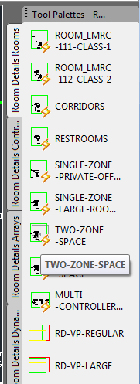

* 1. Visual to Match Steps
     1. This example demonstrates where to insert the block

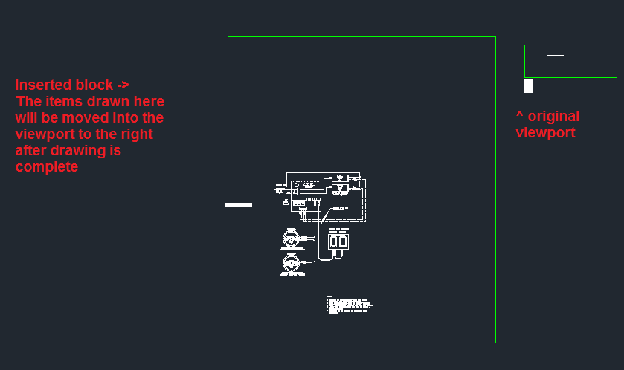

## Additional room items

* **Identify which extra parts you will need and place them in the room**
  1. Parts
     1. Arrays
        1. Large combinations of devices
        2. Visibility states and parameters to quickly modify them
        3. Ability to burst down to individual product level dynamic block

to swap the products in the array around

* + - 1. Example, occupancy sensor can be toggled between LMDC-100 and LMUC-100 after the array is bursted
    1. Devices
       1. Individual product level dynamic blocks
       2. Ability to swap between states for different parts of similar type
    2. Connectors
       1. LMRJ connectors
       2. Dynamic cables with stretch parameters
* **Connect additional DLM items with custom pline commands**
  + P1
    - Starts custom pline command
    - Connection only
    - Type P1 to start
    - Type C to end the pline
  + P2
    - Starts custom pline command
    - Deletes anything under the drawn line
    - Type P2 to start
    - Type C to end the pline
* **Use the RD_ELCU-200-STACK when adding to room controllers:**
  + LMRC-21X
  + LMRC-10X
  + Insertion point connects directly to neutral node on the controller
  + These are the common case so the connections are simple to toggle
* **Use the built in visibility states for ELCU’s on room controllers:**
  + LMRC-2XX
  + LMRC-11X
  + These are the unique cases
  + They don’t follow the same format as the LMRC-21X controllers so they are not part of RD_ELCU-200-STACK
  + Instead, they are part of the controller blocks
  + You can toggle them on and off
  1. Visual to Match Steps
     1. This example demonstrates how to add additional items
     2. To match Bill of Materials



* + 1. Need to add:
       1. LMDI-100
       2. ELCU-200
       3. ELCU-200

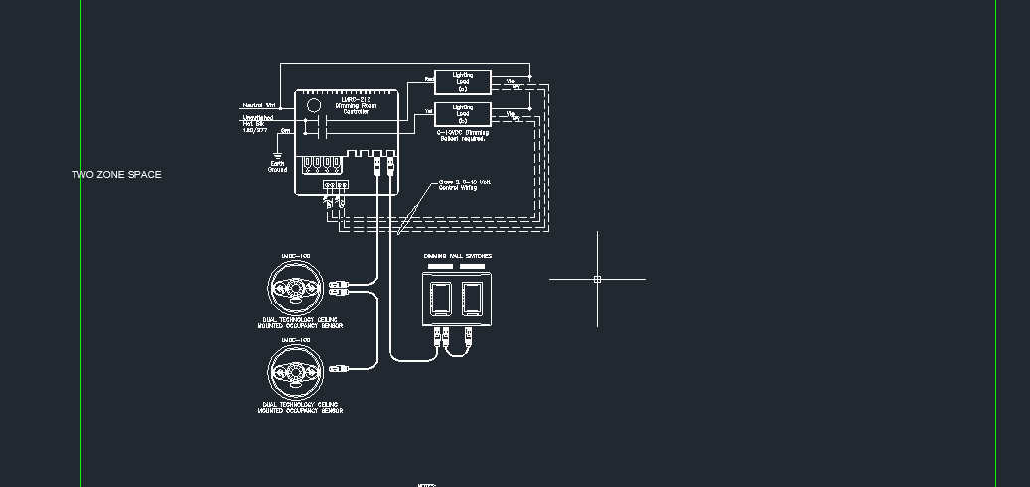

* + - 1. Find dynamic input device from Room Details tool palettes

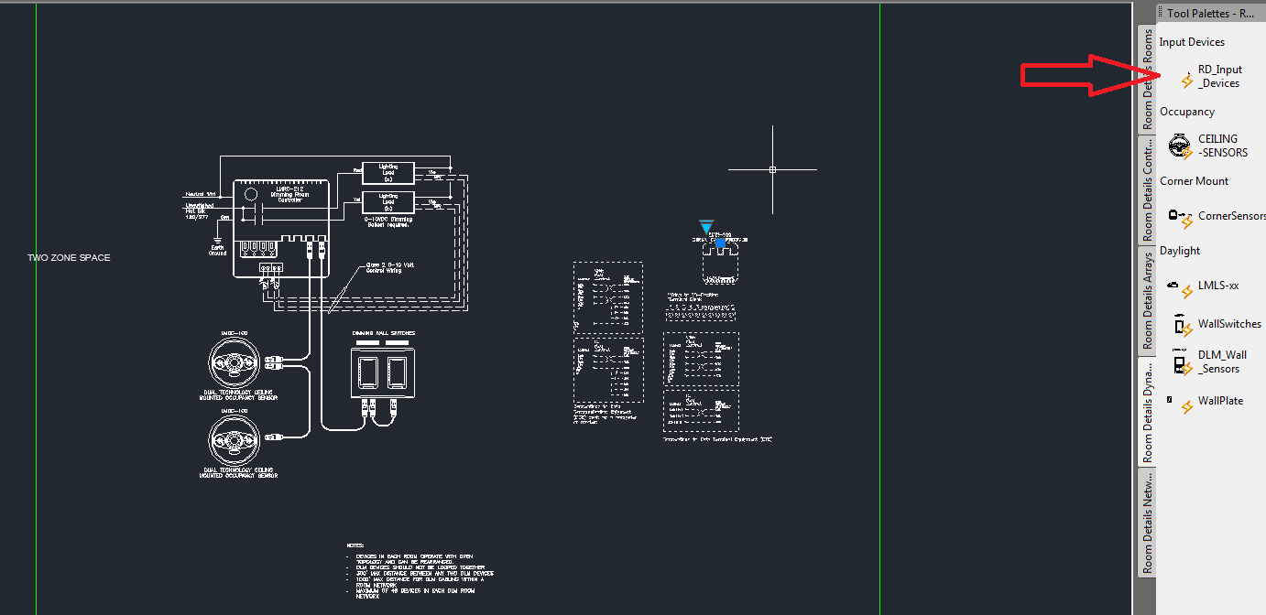

* + - 1. Find switch bank array from Room Details tool palettes

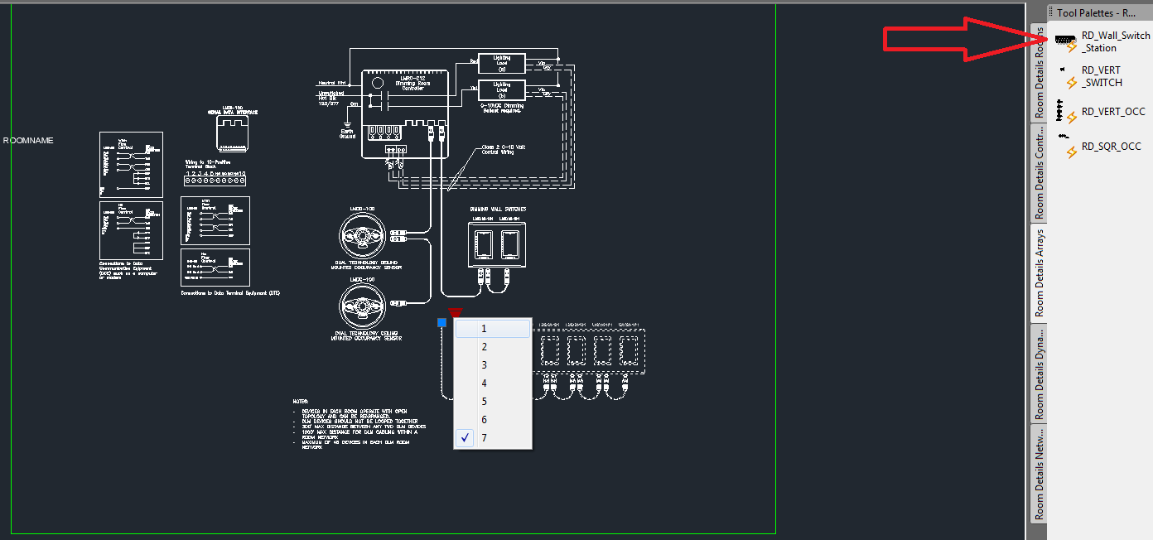

* + - 1. Set visibility states to desired choices, add LMRJ connectors and connect with P1 and P2 commands

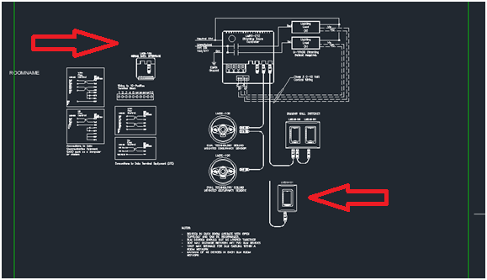

* + - 1. P1 command when only connecting points

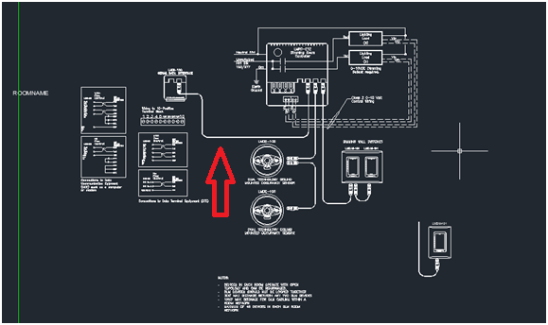

* + - 1. Use P2 command to delete anything under new polyline in between second and second to last points
         1. This command requires at least 4 input points
         2. It will delete anything it finds between the second and second to last point

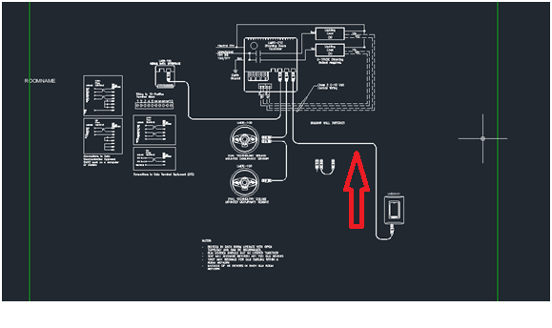

* + - 1. Connect ELCU
         1. The ELCU-200 stack connects to the neutral wire of the LMRC-21X and LMRC-10X room controllers

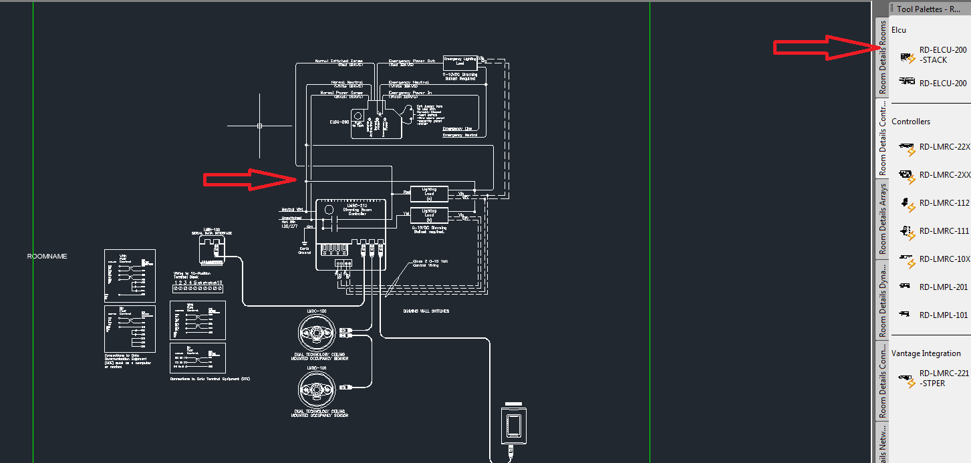

* + - 1. Set the ELCU number state
         1. The ELCU 200 stack contains 3 separate blocks
         2. You can hide or show them with the number state
         3. The main block controls how many ELCU’s are displayed

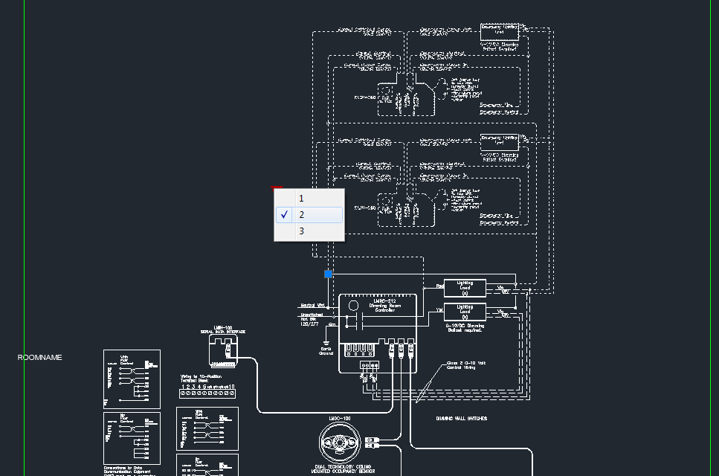

## Attributes

* **Always fill out attributes before bursting any block**
* **After bursting, attributes are lost and they are represented as text**
* **Attributes shared between devices have the same name so you can select multiple blocks at once and fill them out together**
* **Fill out ELCU and Controller attributes**
  + There are shared by the RD_ELCU-200-STACK and Room Controller
  + They can be filled out together by selecting them at the same time and using the properties panel
  + Leave RD_ELCU-200-STACK as a complete block until these are filled out
  + Then burst at the end if you want to
  + LOAD_1 for the loaded wired to the emergency relay
  + LOAD_2 for the loaded wired to the emergency relay
  + LOAD_3 for the loaded wired to the emergency relay
* **Fill out room Controller attributes**
  + This attribute is unique to the Room Controller
  + Select it by itself and use the properties panel to fill it out
  + CIRCUIT_IN for the feed into the room controller
  1. Visual to Match Steps
     1. This example demonstrates how fill out attributes
     2. Set the attributes for the LOAD_1, LOAD_2, LOAD_3
        1. The controller and ELCU-200-STACK share the same attribute names for the three possible loads
        2. **It’s best to fill out attributes before bursting the ELCU-200-STACK**
        3. After bursting, the attributes get turned into text

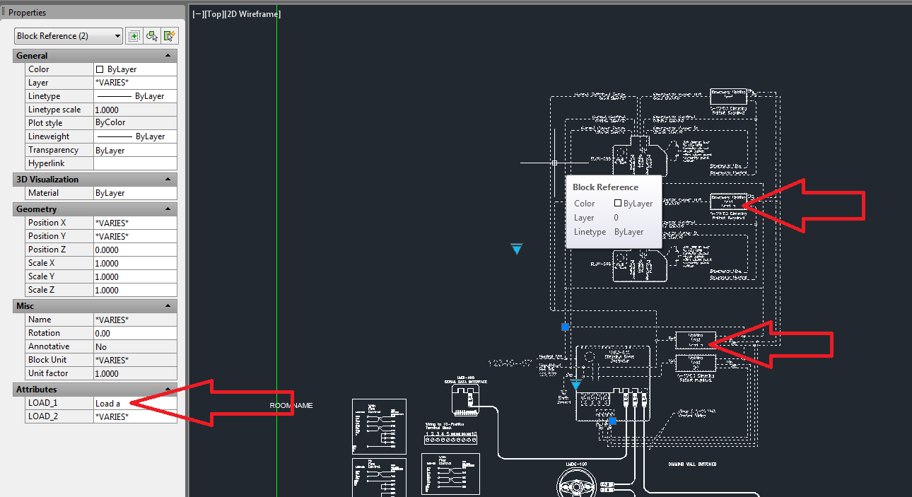

* + - 1. Set the attributes for the CIRCUIT_IN
         1. Only the ROOM controllers have this attribute

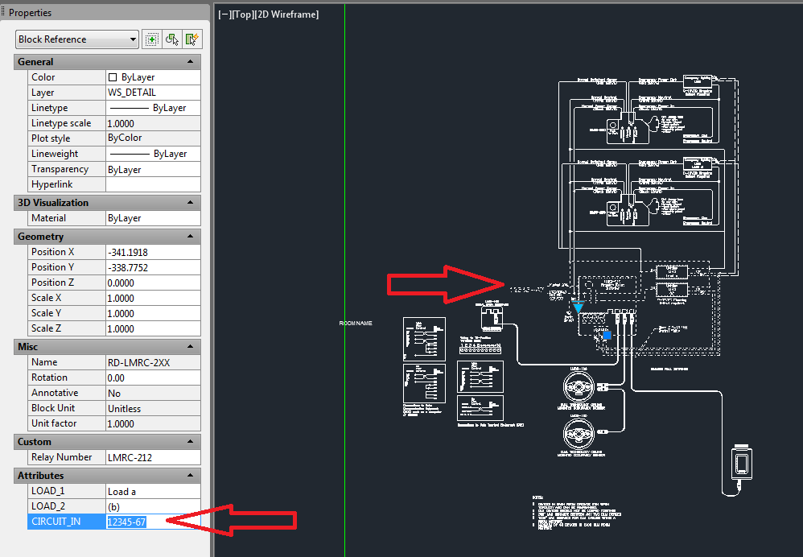

## Set ECLU connection states

* **Always fill out attributes before bursting any block**
* **Burst the ELCU-200-Stack**
* **Choose how each ELCU will connect to controller loads**
  1. Visual to Match Steps
     1. Burst the ELCU-200-STACK
        1. Inside the ELCU-200-STACK there are 3 separate ELCU’s

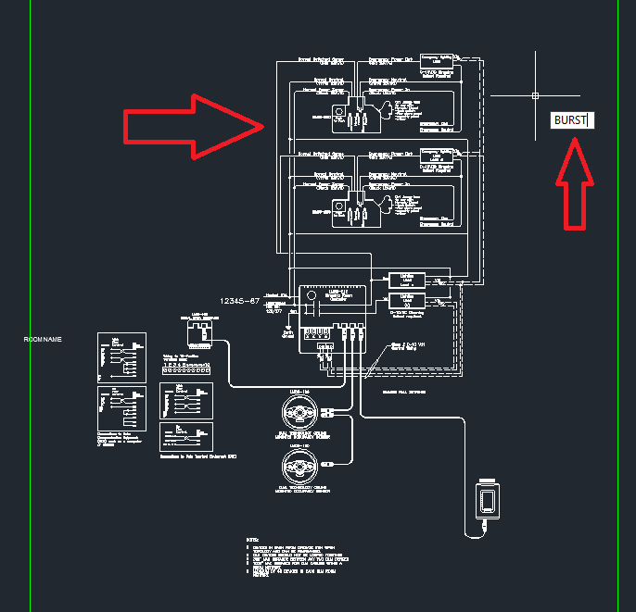

* + 1. Set the ELCU Relay state
       1. Inside the ELCU-200-STACK there are 3 separate ELCU’s
       2. Each can be toggled to connect to the Room Controller loads independent of the others

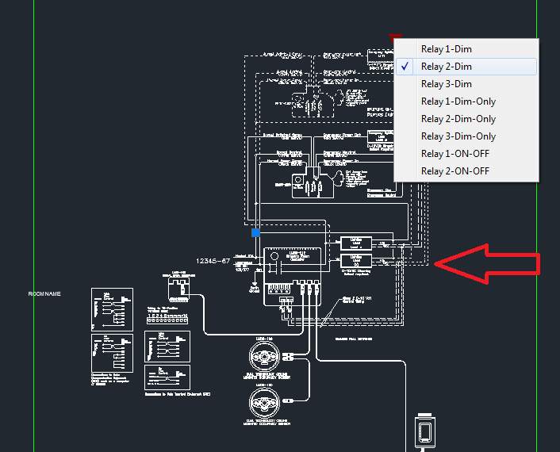

* + - * + The –ONLY is used when there are no other ELCU’s in the way, the lines carry straight through instead of connections to another ELCU

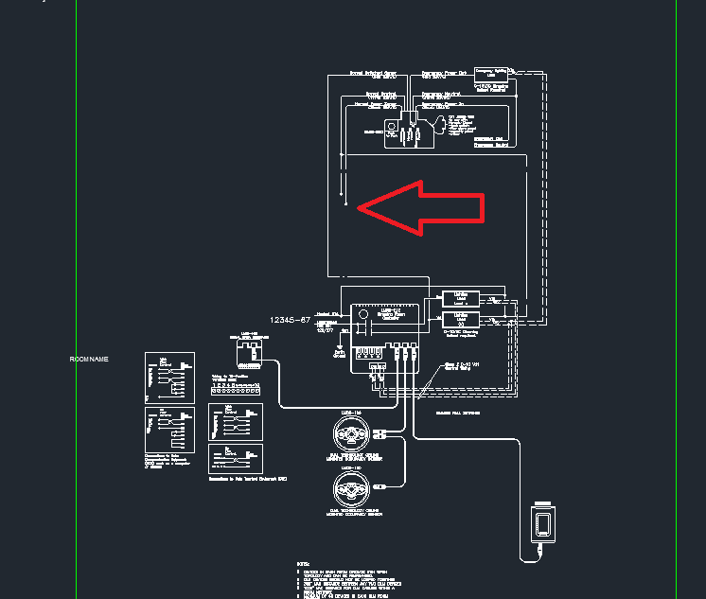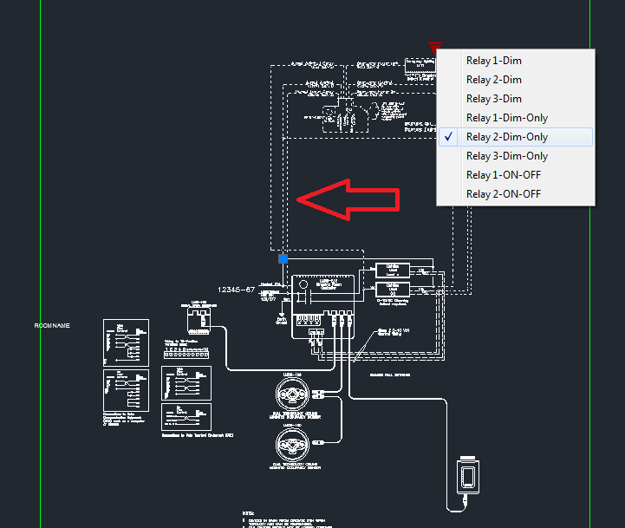

## Scale rectangle in model space and add additional items

* **Scale rectangle to fit room**
  + Each block has a 8.5X11 model space rectangle drawn (green)
  + You can scale the size of it as long as you maintain the ratio
  + There are different color viewports for each size
  + Green (8.5 X 11)
  + Yellow (11 X 17)
  + Red (22 X 34)
  + Use whichever size you need
  + Use the SCALE command to make any custom fits needed
  + It’s also possible to rotate all the products, except the rectangle, in model space to take advantage of the shape of the rectangle
  + At the end, RDVIEWPORTS will set up viewports based on the rectangles
  1. Visual to Match Steps

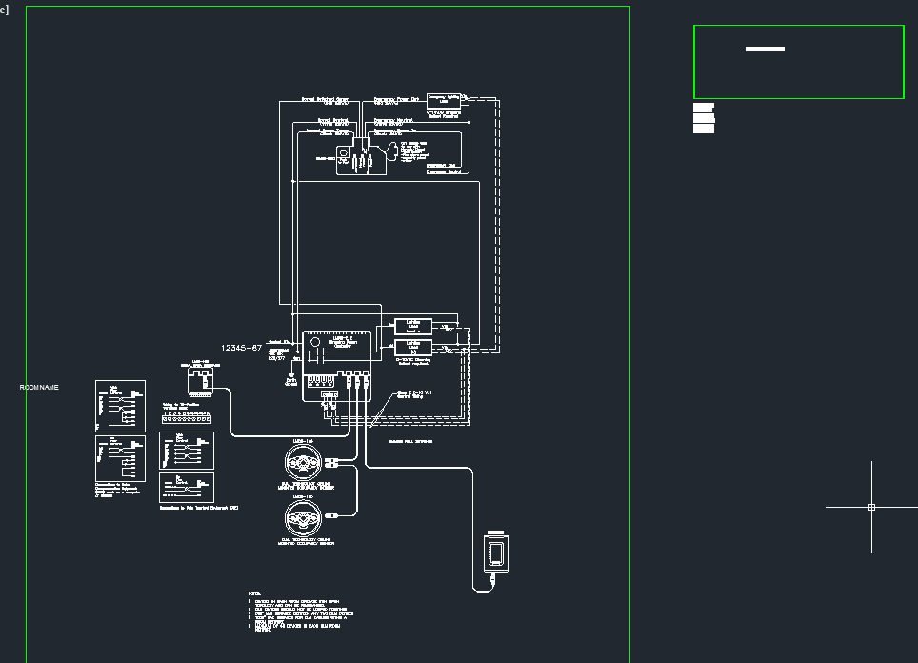

* + 1. Delete viewport from manually inserted Room block

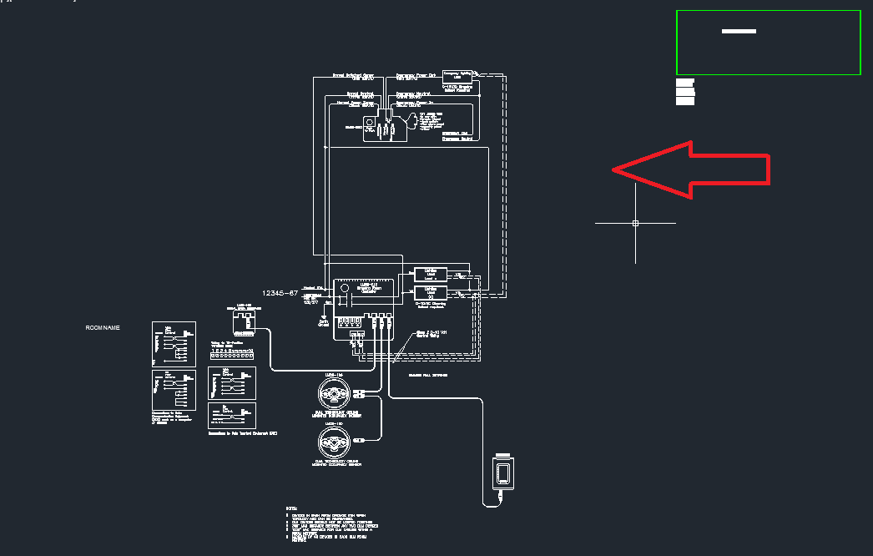

* + 1. Add additional items to original viewport
    2. Scale original viewport to fit everything

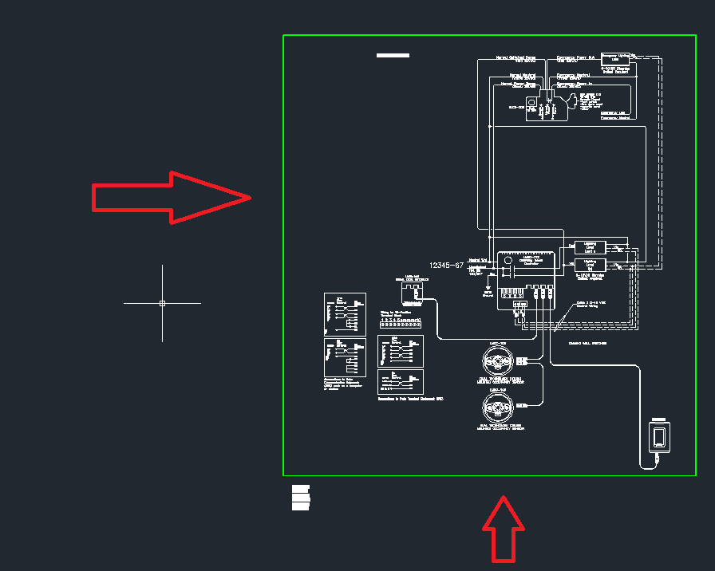

## Repeat 3-7

* Repeat until all Rooms are complete

## Use RDVIEWPORTS to set up all viewports in paper space

* Burst all blocks created by the function, so they are in separate pieces.
* This command is still in development
* It takes 1 minute for 20 viewports
  + **Realize that this will slow your AutoCAD down**
  + **Save all drawings before using this command**
* Type RDVIEWPORTS to set the paper space tabs for each Room